Game Design Document

Fill up the following document

1. Write the title of your project.

Save the goat.

1. What is the goal of the game?

To place all the goat characters on the right place .

3.Write the brief story about your game.

There are four lion character which are placed at the corner.There are 21 tokens name as goat which are present outside the board.The player has to place the goat tokens on the board such that the line can’t jump over it .If the goat is placed in the position where lion can jump over it then that particular goat is out of the game.Lion can only move in the direction of lines.

1. Which are the playing characters of this game?

* Playing characters are the ones who respond to the user based on the input from the user.
* Cars, monkeys, dinos, wizards, etc., are the playing characters in the game.

|  |  |  |
| --- | --- | --- |
| Number | Character Name | What can this character do? |
| 1 | goat | The player has to put this token on the board such that the lion can’t eat them. |
| 2 |  |  |
| 3 |  |  |
| 4 |  |  |
| 5 |  |  |
| 6 |  |  |
| 7 |  |  |
| 8 |  |  |

1. Which are the Non-Playing Characters of this game?

* Non-Playing characters are the ones that don't have an action or behavior when the user interacts with the game.
* Hurdles, stones, bananas, coins, etc., are non-playing characters in the game.

|  |  |  |
| --- | --- | --- |
| Number | Character Name | What can this character do? |
| 1 | lion | Lion can move in the direction of lines and kill the goat by jumping over it. |
| 2 |  |  |
| 3 |  |  |
| 4 |  |  |
| 5 |  |  |
| 6 |  |  |
| 7 |  |  |
| 8 |  |  |

Draw your imagination of this game. What does this game look like?

* Draw the game either on your computer or on paper.
* Add images of the game scenes to show each of the playing and non-playing characters at least once.

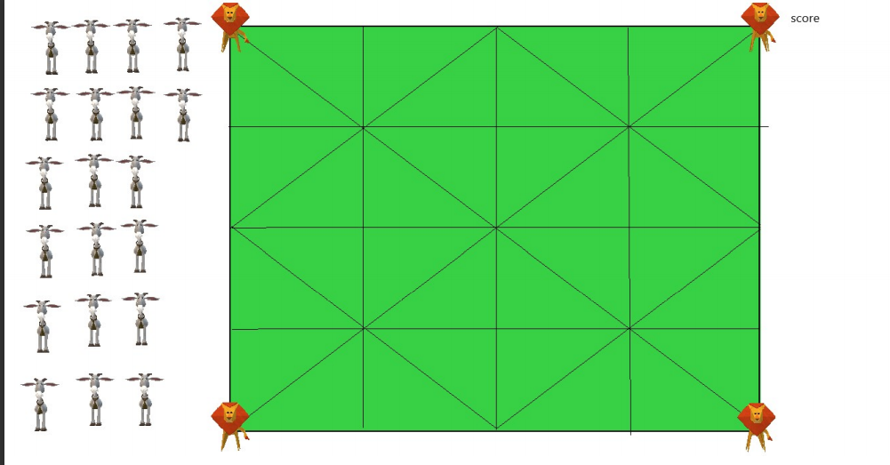

How do you plan to make your game engaging?

The player has to put all the goats on the board .